**Arduino Uno Black Case R3 by SB Components**

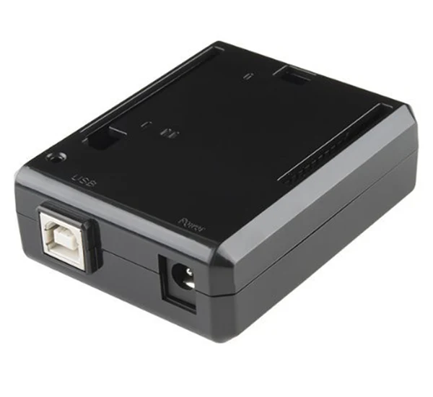

The Arduino Uno Black Case R3 by SB Components is a protective enclosure designed specifically for the Arduino Uno R3. Here are some details and features you might find useful:

**Features:**

1. **Material**: Typically made of durable ABS plastic, which provides good protection against physical damage and environmental factors.
2. **Design**: The case is designed to fit the Arduino Uno R3 precisely, ensuring all ports, pins, and headers are accessible.
3. **Ventilation**: Often includes ventilation slots to prevent overheating and ensure proper airflow.
4. **Mounting Options**: Some cases offer mounting holes or slots to allow for easy attachment to surfaces or integration into larger projects.
5. **Transparency Options**: Some versions may be available in transparent or semi-transparent plastic, allowing visibility of the board's status LEDs.
6. **Assembly**: Usually involves a simple snap-together or screw-together assembly process.

**Benefits:**

* **Protection**: Shields the Arduino board from dust, debris, and accidental short circuits.
* **Organization**: Helps keep your project neat and tidy, especially if you're incorporating it into a larger setup.
* **Port Access**: Maintains easy access to USB, power, and other essential ports without needing to remove the board from the case.
* **Aesthetics**: Provides a clean, professional look to your projects.

**Usage Tips:**

* **Check Compatibility**: Ensure the case is specifically for the Arduino Uno R3 model, as slight variations in board design can affect fit.
* **Proper Ventilation**: Ensure that the case is placed in a well-ventilated area to prevent overheating, especially if running intensive applications.
* **Secure Mounting**: If the case includes mounting options, make use of them to secure your Arduino in a stable position, which can help avoid accidental damage.

Overall, the Arduino Uno Black Case R3 by SB Components is a practical accessory that enhances the durability and usability of your Arduino projects.

<https://shop.sb-components.co.uk/>

<https://shop.sb-components.co.uk/products/arduino-uno-black-case?_pos=1&_sid=b32c7e539&_ss=r>